

MS office: Postlab

Fatmeh M Fawaz

ID : 201400676

EECE 200 Section 5

Friday October 18, 2013

REPORT GRADING

|  |  |
| --- | --- |
| Expected Features |  |
| 1. Title Page: everything centered  including title, name, date, etc. | /6 |
| 2. Typed Report using proper structure *Introduction* followed by *Work Description* followed by *Conclusion* followed by *References* | /6 |
| 3. Professionalism: spacing, 11- or 12-point font, grammar, spelling, punctuation, language, consistency, writing tips followed | /13 |
| 4. Introduction: motivation and objectives of work, overview, report organization | /8 |
| 5. Modeling process description (Work Description/Modeling Process) | /8 |
| 6. Cone equations (MathType) | /8 |
| 7. List of useful Excel tools (Work Description/Tools) | /8 |
| 8. Graphs - graph placed in a figure similar to Figure 1 (Work Description/ Results) | /8 |
| 9. Excel spreadsheet with graph and formulas (Work Description/Results) | /13 |
| 10. Discussion of results (Work Description/Results) | /8 |
| 11. Conclusion | /8 |
| 12. References – find and cite at least 3 references related to this assignment. | /6 |
| TOTAL SCORE | /100 |

Introduction

## Motivation:

Curiosity for the knowledge to be able to completely manipulate excel but also Microsoft office to write complex equations.

## Objectives:

-Learn what are the many basic system mechanisms in excel (i.e. why the cursor changes and how to use excel to input multiple values)

-How to implement a function in excel and apply it to a series of values but also affect the result in accordance to the initial values.

-Build a graph using the results and values inputted and/or obtained via the functions implemented.

-Use Microsoft Word functions (i.e. MathType) to write a set of equations and matrices.

## Overview:

We aim at viewing how the volume of a cone and its area varies depending on its radius. We shall study this by viewing the graph of the variation in accordance to the radius. For that reason, we will be using excel to input different values of the radius and see how the volume and area of the cone varies.

## Outline:

Introduction:

-Motivation

-Objectives

-Overview

-Outline

Work Description:

-Background

-Cone Modeling Process

-Tools

-Results

Conclusion

References

Work Description

# Background:

A few facts about cones1:

-A cone has a flat base

-It has one curved side

-It is not a polyhedron because of its curved surface

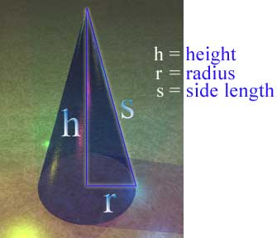-The surface area of its base is ***π*** × r2

Figure : A cone

-The surface area of its side is ***π*** × r × √ (r2+h2)

-Its volume is ***π*** × r2× (h/3)

-The sharp end of a cone is called the vertex or apex

-The flat part is the base

-An object shaped like a cone is said to be conical

(view figure.1)

“Excel is an electronic [spreadsheet](http://spreadsheets.about.com/od/s/g/spreadsheet_def.htm) program that can be used for storing, organizing and manipulating [data](http://spreadsheets.about.com/od/d/g/data_definition.htm).

When you look at the Excel screen you see a rectangular table or grid of [rows](http://spreadsheets.about.com/od/glossary/g/row_definition.htm) and [columns](http://spreadsheets.about.com/od/c/g/Column_defined.htm). The horizontal rows are identified by numbers (1,2,3) and the vertical columns with letters of the alphabet (A,B,C). For columns beyond 26, two or more letters such as AA, AB, AC, identifies columns.

The intersection point between a column and a row is a small rectangular box known as a [cell](http://spreadsheets.about.com/od/c/g/cell_ref_def.htm). A cell is the basic unit for storing data in the spreadsheet. Because an Excel spreadsheet contains thousands of these cells, each is given a [cell reference](http://spreadsheets.about.com/od/c/g/cell_ref_def.htm) or address to identify it.

The cell reference is a combination of the column letter and the row number such as A3, B6, AA345.”2

What is Mathtype? According to ehow3: “MathType is a software application used to add complex mathematical equations to documents such as word processing documents. The MathType application allows you to create equations that include a range of mathematical symbols and typographical conventions, such as square root symbols, fractions, and superscript and subscript items. You use MathType's equation creation interface to build the equation so that you can import it into your document. You can build a sample equation to see how MathType functions.”

Cone Modeling Process:

The first row is used to input the title and name of the user. The first column serves to assign the variables; here the variables are the height (cm), radius (cm) and radius increment (cm) of the cone.

The second row assigns the initial value of the radius, while stating the fixed values of the increment and the height.

The sixth column assigns the many values of the radius, including the initial value, which is the value inserted in the B8 cell (radius variable initial value). The other values of the radiuses are obtained by adding the increment (B9 cell) to the previous value of the radius, knowing the first value is that of B8.

The seventh column assigns the values of the volume of the cone, whose variation is affected by the variation of the values of the radius. The volume is written as ***π*** × r2× (h/3).

The eighth column assigns the values of the surface area of the cone, whose variation is also affected by the variation of the values of the radius. The area is written as ***π*** × r × √ (r2+h2).

We then create a chart using excel to draw the variation of volume and area (two Y-axis) in opposition to the differing values of the radius (X-axis).The chart function on excel can be used to assess other data types.

On Word, we use MathType to insert equations containing the power function, the integral function, the root function, but also matrices. The following are the cone equations:

EQUATIONS

The system of linear equations



is written in matrix form as follows



rms value of current=

Maxwell’s equations are very important in electrical engineering



## Tools:

In order to enter a function in excel, we start by writing it starting with the symbol “=”, we assign the variables by their subsequent value cells and scroll down to retain it for multiple values of the variable. In this case, for the radius affected by the increment, we use the formula: =F7+B9 in the cell F8, where F7 is the previous value of the radius. We proceed by replacing F7 in the cell F9 by F8. However, the increment has one fixed value. Therefore the correct formula is: =F7 +$B$9. The “$” can be used make the variable whose value is in the cell unchanged whilst the values of other variables do change. Thus we obtain the values of an arithmetic sequence with r = increment (B9 cell) and initial value equal to the initial value of the radius (B8 cell).

The cone volume can be obtained using the formula: =(1/3)*PI()*$B$7*F7^2, and that of the cone’s lateral area is =PI()*F7*($B$7^2+F7^2)^0.5. We use the chart tab>chart type function to insert a chart and change its settings in order to have a chart with two Y-axis’ (for the volume and area) and one X-axis (for the radius). The settings differ based on the version of excel which is used. We may insert functions on excel and we can use the “help” function for assistance on entering a function.

MathType is in itself a tool implemented on MS word, which is used to write mathematical expressions.

# Results:

According to the chart obtained through excel, we may notice that whenever the radius increases, the volume and lateral area of the cone increase. The volume of the cone is relatively smaller than its lateral area. However at radius=21 cm, the area and volume are both equal to 1913. When the radius is larger then 21cm, the volume becomes higher than the area. (View figure 2)

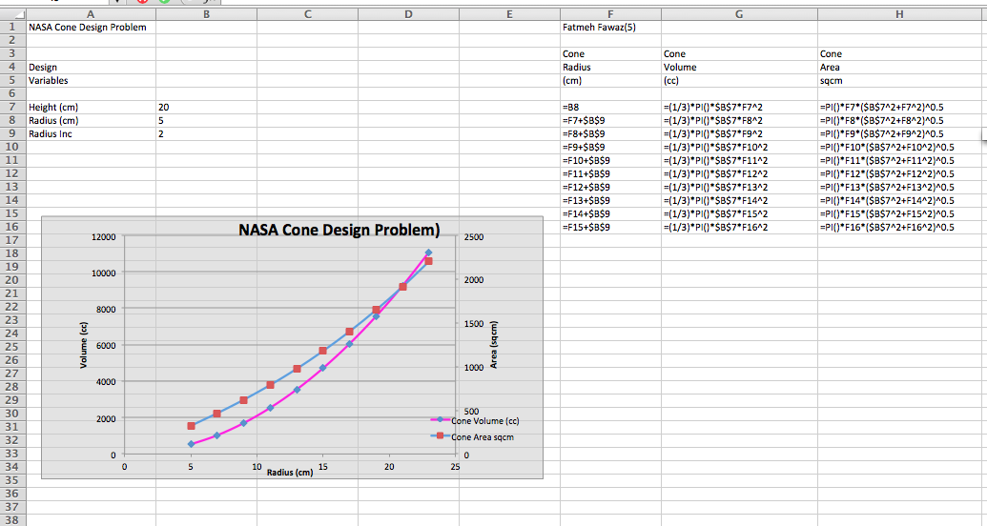

Figure : Excel Screenshot

Conclusion

Excel is useful for inputting multiple values and series and can be used to repeat multiple functions without being forced to input the same function every time. Excel has the capability to pick up on a pattern, thus saving time and substituting processes of extensive calculations. Excel can also be used to draw charts and organize material into tables. Mathtype is a useful function on Microsoft Word, which can be used to write equations and matrices and expressions containing other mathematical figures and characters.

References

1Facts were found on: <http://www.mathsisfun.com/geometry/cone.html>

2 <http://spreadsheets.about.com/od/tipsandfaqs/f/excel_use.htm>

3 <http://www.ehow.com/how_5187435_use-mathtype.html>